

University of Ontario Institute of Technology (UOIT)

Faculty of Engineering and Applied Science (FEAS)

Department Of Electrical, Computer, And Software Engineering (ECSE)

**Software Project Management**

**(SOFE 3490)**

Lab #1 Submission | Screenshots

Okwudili Ezeme

Winter 2020

Group Members

Aryan Kukreja (100651838)

# Screenshots

The following document contains the screenshots of every step in the Lab document.

## Create a Git repository using the cheat-sheet commands

Created a directory to host the repository, and initialized a blank repository within it.

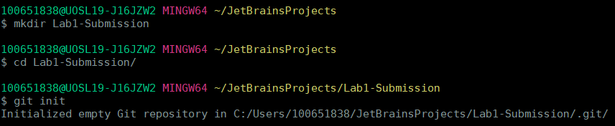

## Edit “Student” file to include your own Student Name & Student ID

The file is created with my name and student number in it. As a test, the **cat** command is used to see if the contents are successfully written.

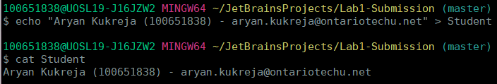

## Commit changes

## This command adds the Student file to the repository, and then commits the entire repository.

## 

## Create IgnoreExample.txt

This command creates the IgnoreFile.txt file and adds it to the repository

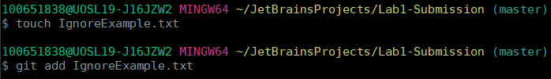

## Edit the content of IgnoreExample.txt and Use git status and screenshot the outcome

The content of IgnoreExample.txt is edited, and to test if the content was added, we use the git status to see if the file was made or not.

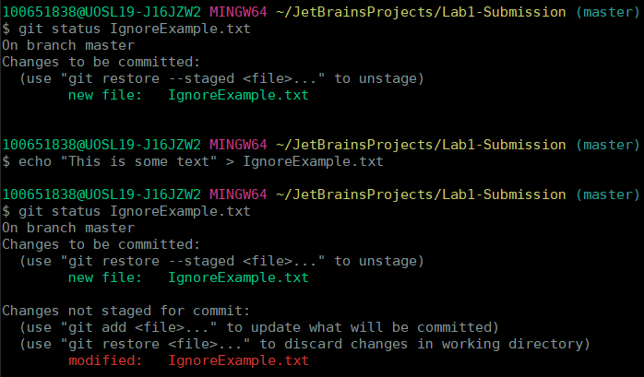

## Commit changes

The changes are committed as shown in the below screenshot. To check that all files are added successfully to the rep, the “**git add .”** command is run as a safety check, before committing again.

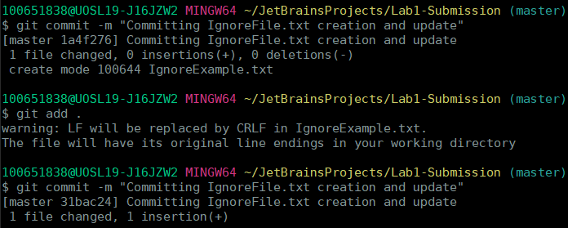

## Add IgnoreExample.txt to .gitignore file





Here, I add the filename **IgnoreExample**.**txt** to ignore that file and save it.



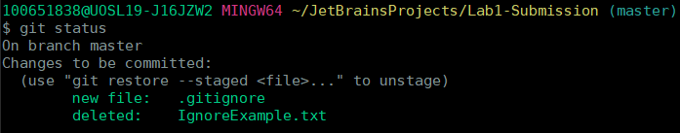

## Edit content of IgnoreExample.txt and Use git status and screenshot the outcome

Now we edit the **IgnoreExample.txt,** and run **git status** to get the output below. As expected, git no longer tracks the **IgnoreExample.txt** file

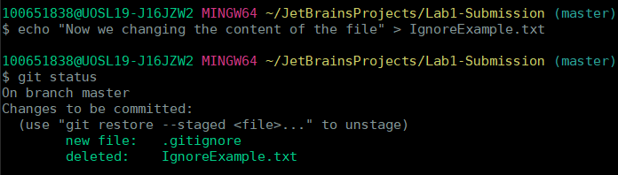

## Create a new branch using git branch

A sample branch called **example** is made with **git branch**.



## Switch to a new branch

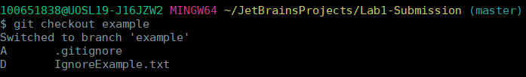

## Edit BranchExample.txt (create this if not present) via notepad command notepad BranchExample.txt

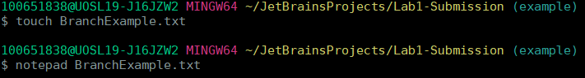

## Use git add for update branch example, commit and use notepad command again

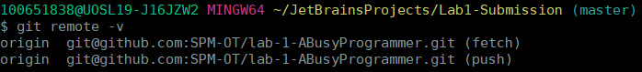



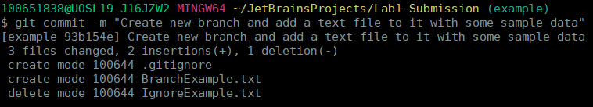

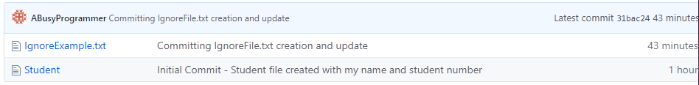

## Switch back to master branch



## Use the same notepad command. Screenshot the outcome

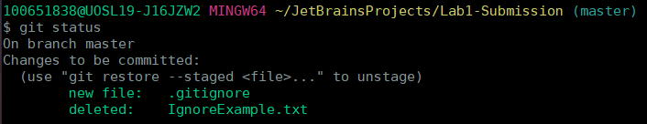

## Remove RemoveExample.txt (create one first if not present)

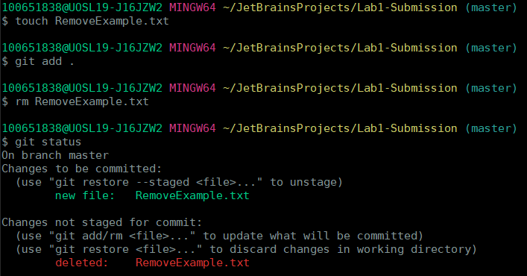

## Commit

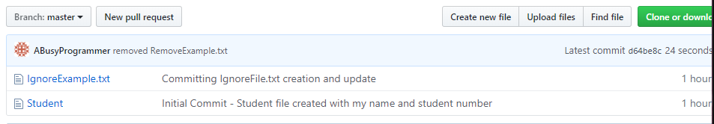

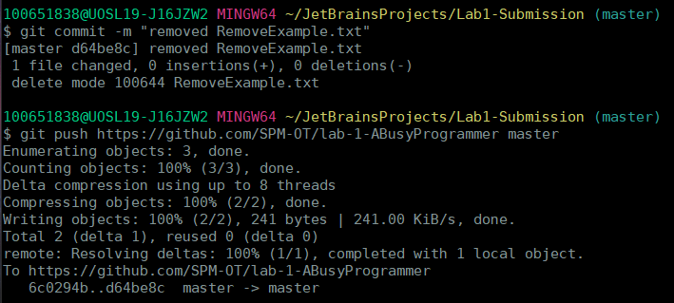

## Use git status and screenshot outcome 5

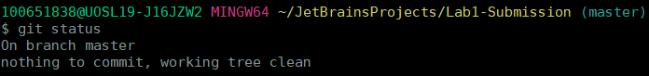

## Use clean command to remove the file completely



## Use git status and screenshot outcome

